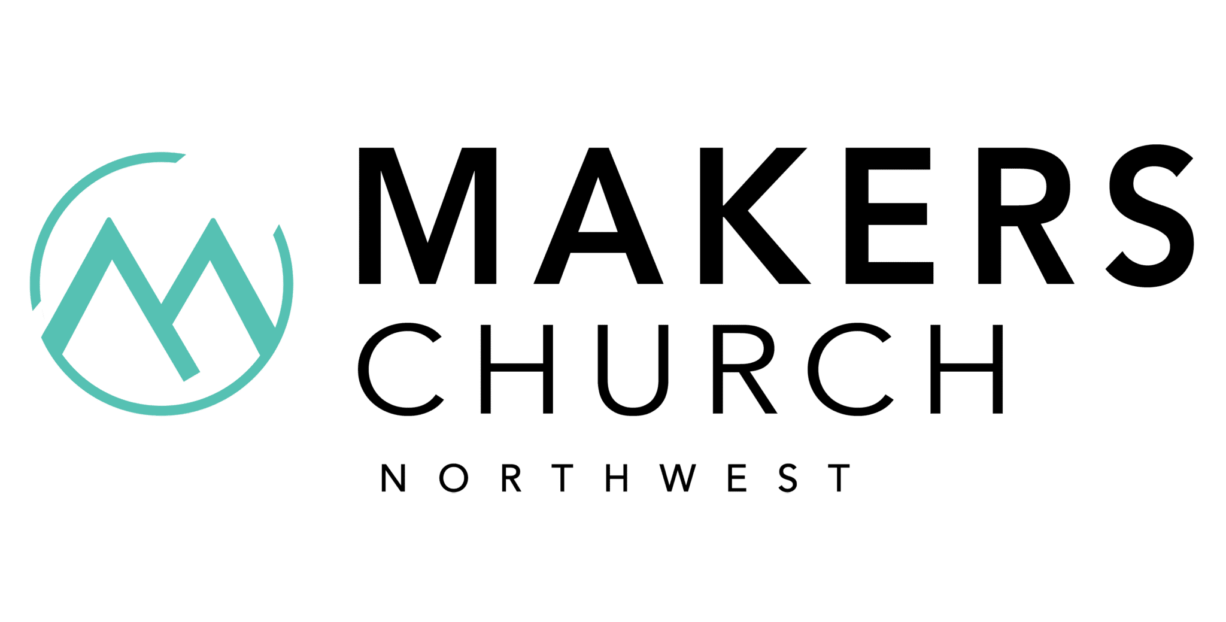Worship Director
Makers Church Northwest
Vancouver, WA 98684
$35,000 - $50,000 a year - Full-time

Full Job Description
Makers Church Northwest is a new church plant in Vancouver, WA, looking for a full-time worship leader who is musically gifted, spiritually mature, biblically grounded, and has a deep understanding of cultural diversity. The ideal candidate has experience leading worship at a similar-sized church and experience in shepherding worship teams. The responsibilities are, but not limited to:
⁃ Work with the Lead Pastor to plan the worship service experiences
⁃ Recruit, Develop, Train, and Manage Volunteer Worship team
⁃ Actively work to create a multi-generational and multicultural team
⁃ Develop a process to regularly identify and deploy new volunteers in the church’s worship ministry
⁃ Shepherd existing and potential worship ministry volunteers through small group involvement
⁃ Develop an annual worship ministry budget and be able to work within that budget.
⁃ Look for ways to inspire non-musical worship experiences for the church body
⁃ Oversee the church’s worship tech ministry.
⁃ Attend all church staff meetings and retreats.
⁃ Oversee the maintenance of all sound/audio/media equipment and instruments
⁃ Record, Produce, and Oversee seasonal original worship projects, i.e., singles, EP, Full Length
Requirements:
⁃ Minimum 2 years experience leading worship in a similar church setting
⁃ Significant skill as a vocalist and instrumentalist.
⁃ Should be proficient in diverse worship styles
- Be knowledgeable in analog and digital mixers
- Be knowledgeable in live and recorded sound
⁃ Be knowledgeable in Propresenter, Planning Center, and Community Church Builder
⁃ Should have experience leading and managing teams.
⁃ A lifestyle congruent with the biblical requirements for leaders
- Lighting and Multimedia a plus!
Anticipated Time Commitments:
1. Weekly Staff Mtgs, Sunday Gatherings, Team Practice
2. Periodical Outreach Events, Network Partnerships, and Leadership Conferences
If interested, contact:
HEATHER FINCH, MINISTRY COORDINATOR

Makers Church Northwest
360.521.6015 | info@makerschurchnw.com
www.makerschurchnw.com

