Thinking Critically in a World of Disinformation

“See to it that no one takes you captive by philosophy and empty deceit, according to human tradition.” (Col. 2:8).

“Timothy, protect what has been entrusted to you, avoiding worldly, empty chatter and the opposing arguments of what is falsely called “knowledge” which some have professed and thereby have gone astray from the faith.” (1 Tim. 6:20-21).

“Do not be conformed to this world, but be transformed by the renewal of your mind, that by testing you may discern what is the will of God, what is good and acceptable and perfect.” (Rom. 12:2).
- Gen Z Emerging in an Information Age

“The empires of the future are the empires of the mind.” Winston Churchill, Harvard Commencement Address, 1943.

Gen. Z is the first generation whose whole life experience to date coincides with the predominance of social media and the reality of big data. Born in the late 90s and early 2000s, they are digital natives who have never experienced life without the internet. They came of age as social media was booming, entered college during a time of digital dependency due to the pandemic, and moved into the workforce that is now being revolutionized by AI.
Every 24 hours:

- 329 million terabytes of information is generated per day. (1 large laptop is about 1 terabyte).
- 333 billion emails are sent.
- 8.5 billion Google searches.
- 3.5 billion snaps on Snapchat.
- 2.45 billion pieces of content posted to Facebook.
- 1.58 billion swipes on Tinder.

90% of the world’s data was created in the last 24 months.

The quantity of knowledge that will become available and be utilized by Gen. Z has no parallel in history. If knowledge is power, what is our responsibility as young adult leaders to prepare Gen. Z to create, handle, discern, and utilize the power of knowledge?

- Information fuels power.

- Information is utilized to win the competitive edge and gain economic power.
- Information is manipulated to create narratives and fuel bias to garner votes and gain political power.
- Information is evaluated to support personal choices and project psychological power.

- Information is currency.
- Information is leveraged transactionally.
- Information is created, manipulated, and shared to get what we want.

- The paradox of the information age: Information exists in a vacuum of understanding and wisdom.
- The greatest paradox of our time: Infinite knowledge abounds in a culture that lacks understanding and wisdom. The danger is that we could rely on machines and robots, programmed by experts, to do the hard work of thinking for us. Such a reliance makes us subject to the manipulation of knowledge creators.
- Recognizing Disinformation as a Currency of Manipulation

- The intent of disinformation, fake news, and conspiracies

- Knowledge is devalued when it is derived separately from critical thinking and fails to contribute to our ability to understand and apply wisdom. Undermining our capacity to think critically disempowers us.

- Information, like other forms of currency, can be easily devalued through forgery and manipulation. But for what purpose?

- When information or knowledge is separated from enabling people to gain a greater level of understanding and wisdom it can be manipulated to gain control.

- Creating and distributing disinformation is the malicious intent to deceive people into an opinion or action they would otherwise not have held or acted upon.
“Today, just a few people at a handful of companies now can shape what billions of human beings think and do.” Former Google Strategist, James Williams.

In order to gain power, the intent of creators and spreaders of disinformation is to:

- Intellectually discredit: A technique to deflect attention away from accusations by attacking the source of the criticism. Applying the term ‘fake news’ often is used as a rhetorical device used to dismiss and discredit information that does not align with a person’s actions or values.

- Emotionally manipulate: Disinformation deliberately plays on people's basic emotions by inciting fear and anger. Putting people into an emotional state significantly increases their susceptibility to believing fake news.

- Socially polarize: The polarization technique involves a deliberate attempt to drive a wedge between different sectors of society. False amplification is a frequently employed tactic that blows up societal divisions by acquiring bots who tweet or retweet polarizing content to flood the discourse on a contested issue.
There is growing concern around the tendency for disinformation to feed social groups to dislike or hate each other at a personal level. This breaks down social cohesion and democratic discourse.
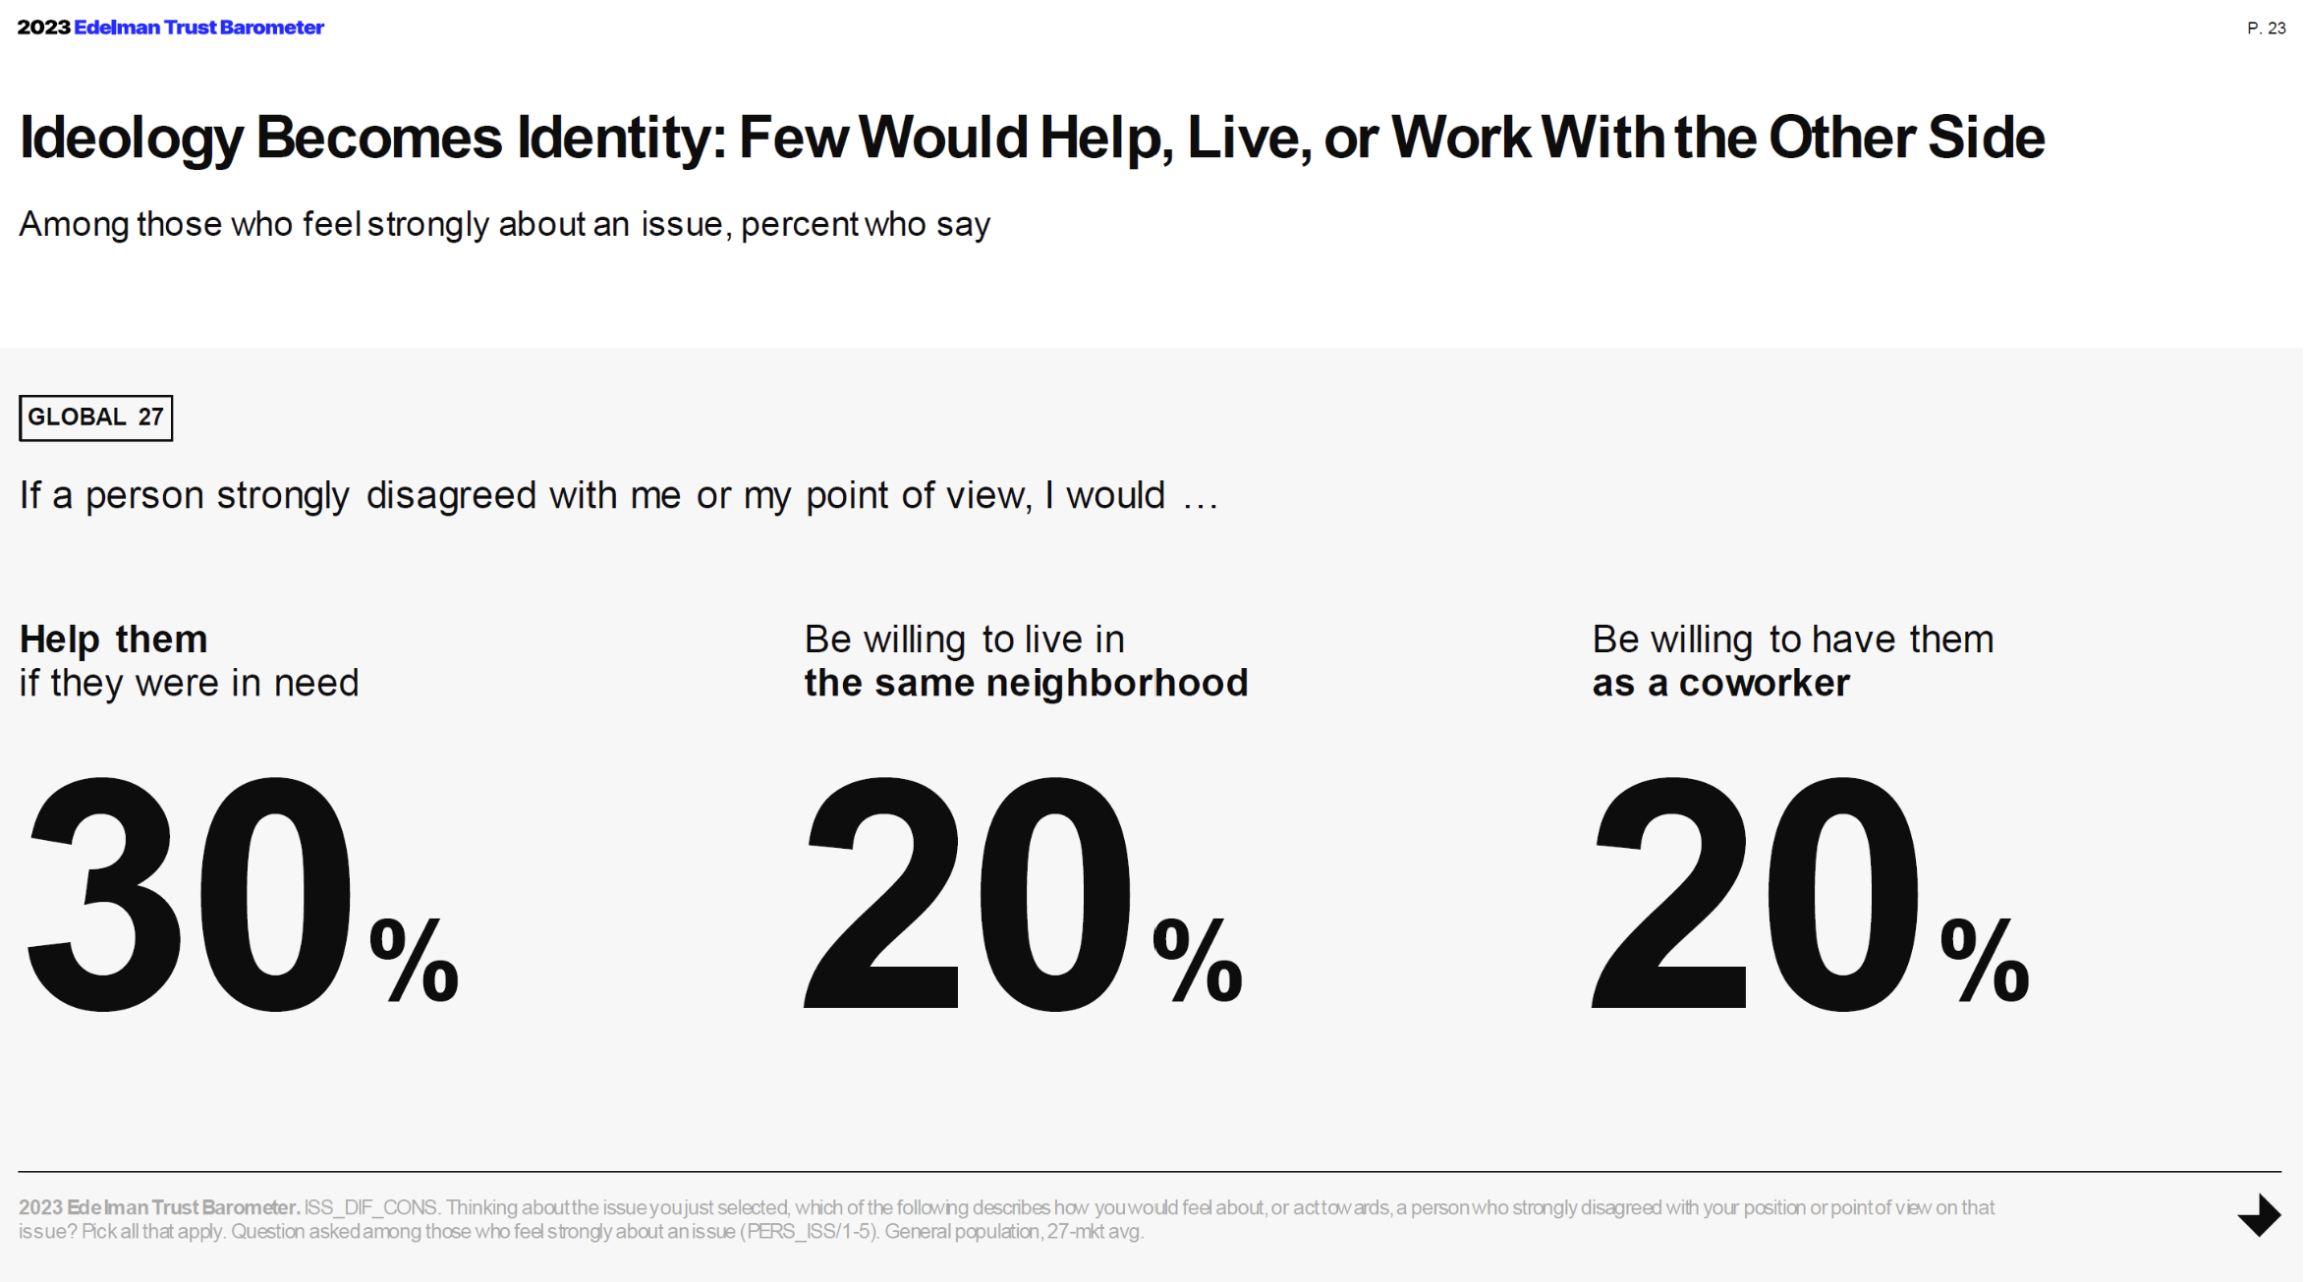
- The appeal of disinformation, fake news, and conspiracies

Religious people/groups are more likely to be susceptible to disinformation and are therefore targeted more frequently.
“The reason why conspiracy theories spread so easily is because they are psychologically attractive; they offer simple explanations for complex events; they restore a sense of urgency and control in a world, increasingly filled with chaos and uncertainty.”

- Theological concerns: Religious people tend to want to make sense of the world around them in light of their theological worldview. People want simple things to understand the world they care about to create apocalyptic alarm.
- Existential concerns: Religious people may want to establish a sense of agency and control over the narrative and world events. More concern over systems being preserved than people being rescued.
- The quest for an individual sense of relevancy: Religious people can use conspiracy theories to separate themselves from an evil world and pose as those with authority and who are in the know.
- The quest for a corporate/herd sense of relevancy: Religious people can use conspiracy theories to find their tribe when they feel marginalized.

- Using Critical Thinking to Dispel Disinformation

- The Daniel Model: Providing Wisdom and Critical Thinking in an Age of Distrust

- Babylon was known as the intellectual and political center of the ancient world.

- The intellectual elite could not be trusted to provide wisdom and critical thinking.

“Then the king commanded…to bring some of the people of Israel…[those] skillful in all wisdom, endowed with knowledge, understanding learning, and competent to stand in the king's palace, and to teach them the literature and language of the Chaldeans…As for these four youths, God gave them learning and skill in all literature and wisdom.” (Dan. 1:4, 17).

Learning: (Hebrew: mada): To discern, to distinguish, to consider.

- The skill to discern. Objective: Understand the authority or intent of information.
The ability to discern is gained by asking questions:
- What level of authority and credibility does the author of the content have?
- To what extent do the author’s views align with the authority of biblical principles?
- Do I feel emotionally manipulated by the author? Is this information inciting an emotional response such as anger, resentment, or fear, more than a rational response toward empathy, understanding, or the application of principled wisdom?
- What appears to be the motivation of the author in providing this content?
  - Is this a marketer who wants to sell me something?
  - Is this a politician who wants my vote?
  - Is this a religious leader who wants my commitment, money, and resources?
- The skill to distinguish. Objective: Understand the accuracy of information.

The ability to distinguish is gained by asking questions:
- Where is your information sourced? Social media or reputable institution?
- What evidence is presented that supports the opinions that are given?
- Does the evidence sound plausible, exaggerated, or realistic?
- What evidence or narratives seem to be ignored or discounted?

- The skill to consider. Objective: Recognize the application of information.
The ability to consider is gained by asking questions:
- To what extent can you agree or disagree with the ideas or information and why?
- Does this content foster discussion with those who may disagree, or is it inflammatory and polarizing?
- How does this content help me understand others who are different from me and engage with them respectfully, even if I still disagree?

- Lead by example

- Exemplify critical thinking in your teaching.
- Encourage Gen. Z’s sense of curiosity.
- Reject intellectual laziness and pride of being entrenched in your own opinion.
- Engage others with humility by respecting and considering their opinions.
- Practice critical thinking and authentic inquiry through dialog and conversation.

Additional Resources

Coming Soon: Mannahouse Accelerate Conference Workshop. (Today’s topic will be expanded with 6 hours of teaching).

Williams, James. Stand Out Of Our Light. Freedom and Resistance in the Attention Economy.

Van Der Linden, Sander. Foolproof. Why Misinformation Infects Our Minds and How to Build Immunity.

Wightman, Rachel I., Sheneman, Jeannie. Faith and Fake News: A Guide to Consuming Information Wisely.

Statistica. https://explodingtopics.com/blog/data-generated-per-day
Williams, James. Stand Out Of Our Light. Freedom and Resistance in the Attention Economy. P.36.
Van Der Linden, Sander. Foolproof. Why Misinformation Infects Our Minds and How to Build Immunity. P.196-201.
Van Der Linden, Sander. Foolproof. Why Misinformation Infects Our Minds and How to Build Immunity. P.59.

