Session 1: The Paradox of the Information Age

Introduction: Thinking Critically in a World of Disinformation

Overview:

- The Paradox of the Information Age
- The Intent of the Disinformation Manipulators
- The Appeal of the Disinformation Manipulators
- Using Critical Thinking to Dispel Disinformation
- Practical Tools to Discern Disinformation
- Critical Thinking and Political Discourse

Key Scriptures:

“See to it that no one takes you captive by philosophy and empty deceit, according to human tradition.” (Col. 2:8).

“Timothy, protect what has been entrusted to you, avoiding worldly, empty chatter and the opposing arguments of what is falsely called “knowledge” which some have professed and thereby have gone astray from the faith.” (1 Tim. 6:20-21).

“Do not be conformed to this world, but be transformed by the renewal of your mind, that by testing you may discern what is the will of God, what is good and acceptable and perfect.” (Rom. 12:2).
- Gen Z Emerging in an Information Age

“The empires of the future are the empires of the mind.” Winston Churchill, Harvard Commencement Address, 1943.

Gen. Z is the first generation whose whole life experience to date coincides with the predominance of social media and the reality of big data. Born in the late 90s and early 2000s:

- Digital natives:
- Came of age:
- Entered college:
- Moved into the workforce:
Every 24 hours:

- 329 million terabytes of information is generated per day. (1 large laptop is about 1 terabyte).
- 333 billion emails are sent.
- 8.5 billion Google searches.
- 3.5 billion snaps on Snapchat.
- 2.45 billion pieces of content posted to Facebook.
- 1.58 billion swipes on Tinder.

90% of the world’s data was created in the last 24 months.

Before we train them how to handle information, we must understand how information is used to attain and project power.
- Information fuels power.

- Information is utilized to gain economic power.
- Information is manipulated to gain political power.
- Information is evaluated to project psychological power.
- Information is currency.
- Information is leveraged transactionally.
- Information is created, manipulated, and shared to get what we want.
- The paradox of the information age: Information exists in a vacuum of understanding and wisdom.
The greatest paradox of our time: Infinite knowledge abounds in a culture that lacks understanding and wisdom.
- Distraction Surplus and Attention Deficit
- Our limited attention span
- Inverse relationship between information abundance and wisdom scarcity:
- Our attention is where:

Former Google Strategist James Williams: “When information becomes abundant, attention becomes a scarce resource.

Nicholas Carr: “The linear mind is being pushed aside by a new kind of mind that wants and needs to take in and dole out information in short, disjointed, often overlapping bursts - the faster, the better.”

Nobel prize-winning economist Herbert Simon in 1971, “In an information-rich world, the wealth of information means a dearth of something else: a scarcity of whatever information consumes. It consumes the attention of its recipients. Hence a wealth of information creates a poverty of attention.”

- “Pay attention.” What is it we pay?
- Our distracted attention span
Our mental attention is directed towards vanity and entertainment rather than generating value.

“This is one reason social media has been so transformative: there is always an audience eager to watch people being shamed, particularly when it is so easy for spectators to join in and pile on.”

“This fusing of entertainment, news, punditry, and citizen participation is a chaotic mess that does not inform people so much as it creates the illusion of being informed.”

We become consumers of poorly sourced information we find on social media.

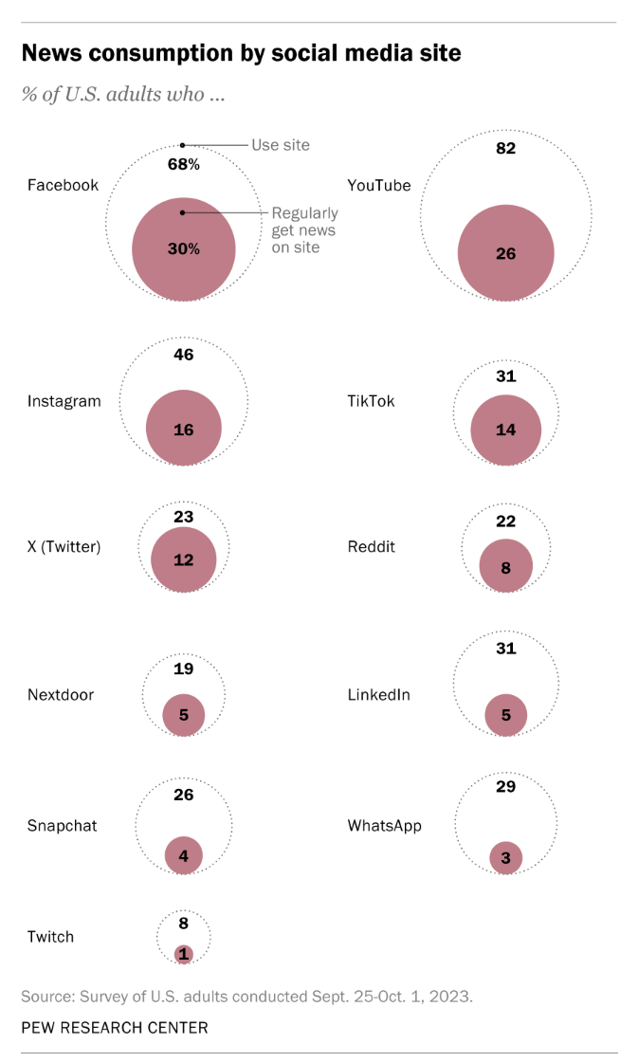

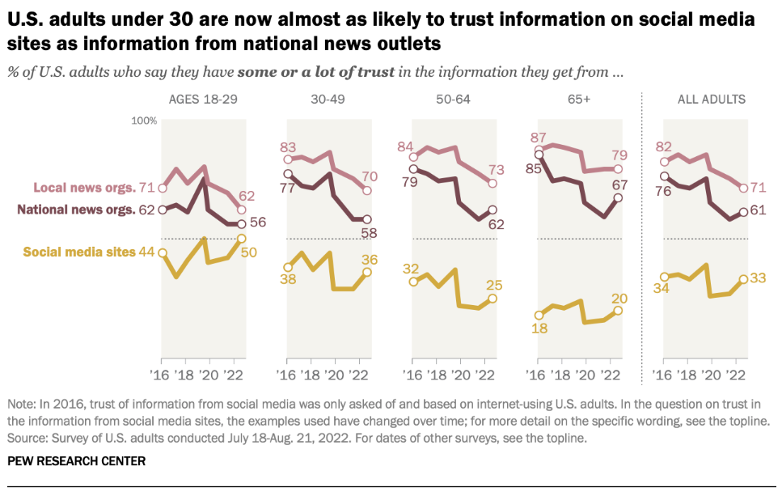

The consequence:
The blame:

The result:
- Distrust of the Knowledge Curators
- The roots of distrust
- Distrust of the establishment:

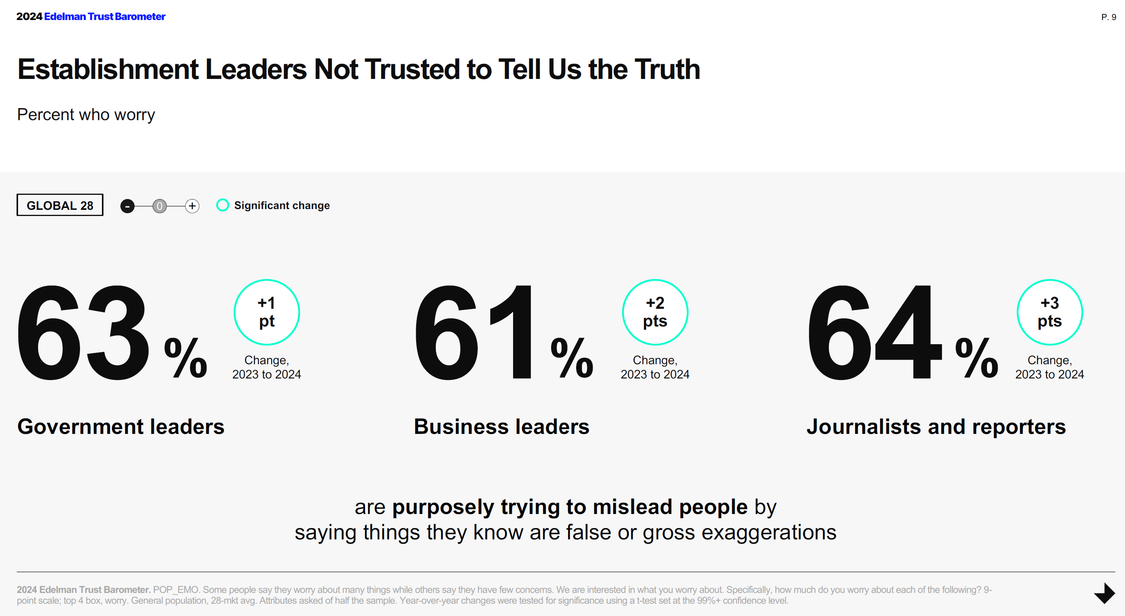

Postmodernism: A culture of citizen experts:

“Maybe the intellectual gulf between the educated elites and the masses is now so large that they simply cannot talk to each other except to exchange expressions of mutual contempt.”
- Distrust of AI:

According to a Reuters/Ipsos poll, more than two-thirds of Americans are concerned about the negative effects of AI and 61% believe it could threaten civilization.

Evangelical Christians were more likely to "strongly agree" that AI presents risks to humanity, standing at 32% compared to 24% of non-Evangelical Christians.

- Roots of distrust in the intellectual establishment:

- Attitude of elitism.
- Disconnect from ordinary people and their problems.
- Bias in academic and mainstream media toward the left.
- The fruit of distrust

“This is one reason why few Americans trust what little news, or newslike programming, they watch. Too many people approach the news with an underlying assumption that they are already well versed in the issues. They do not seek information so much as confirmation, and when they receive information they do not like, they will gravitate to sources they prefer because they believe others are mistaken or even lying.”

Session 2: The Intent of the Disinformation Manipulators

Key Scriptures
“I will get my knowledge from afar and ascribe righteousness to my Maker. For truly my words are not false; one who is perfect in knowledge is with you.” (Job 36:3-4).
- The Intent of the False Prophets

“Your prophets have seen for you false and deceptive visions; they have not exposed your iniquity to restore your fortunes, but have seen for you oracles that are false and misleading.” (Lamentations 2:14).

INTEREST | AUDIENCE | MESSAGE
Motivated by | Sought favor with | Promised
Motivated by | Sought favor with | Promised

“Do not listen to your prophets and diviners who are among you to deceive you, and do not listen to the dreams that they dream, for it is a lie.” (Jer. 29:8-9).
- The Intent of Disinformation Manipulators

- The intent to disempower.

- Knowledge is devalued when it is derived separately from critical thinking and fails to contribute to our ability to understand and apply wisdom.
Undermining our capacity to think critically disempowers us.

- When information or knowledge is separated from enabling people to gain a greater level of understanding and wisdom, it can be manipulated to gain control.

- Creating and distributing disinformation is the malicious intent to deceive people into an opinion or action they would otherwise not have held or acted upon.
- The intent to manipulate.

- By devaluing information through forgery and manipulation.

Comparing the intent of different types of disinformation:

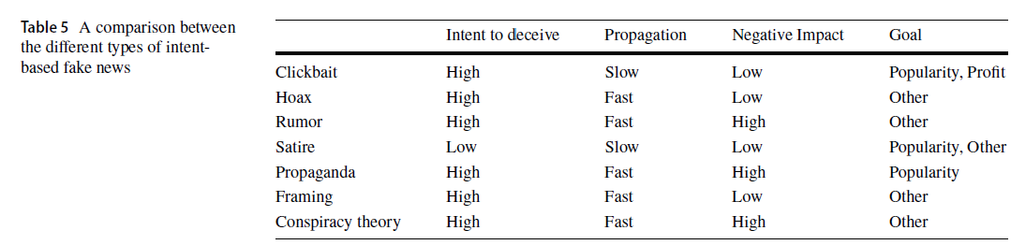

- By emotional manipulation.
Putting people into an emotional state significantly increases their susceptibility to believing fake information.

- By intellectually discrediting authorities or experts.
Understanding Trump’s Twitter intentions. Trump’s tweets were divided into four strategies:
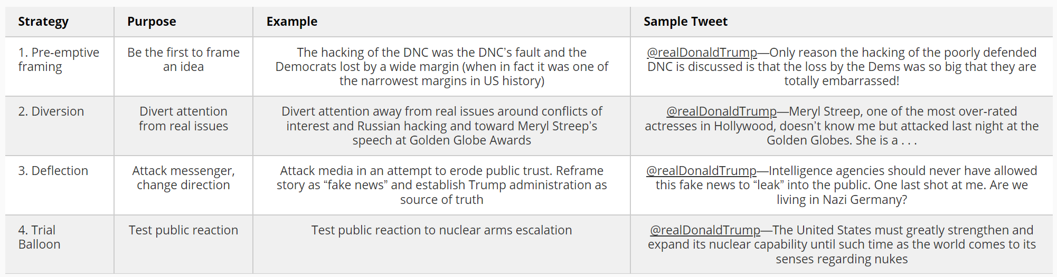
- The intent to polarize.

To socially polarize:
False amplification is a frequently employed tactic that blows up societal divisions by acquiring bots who tweet or retweet polarizing content to flood the discourse on a contested issue.

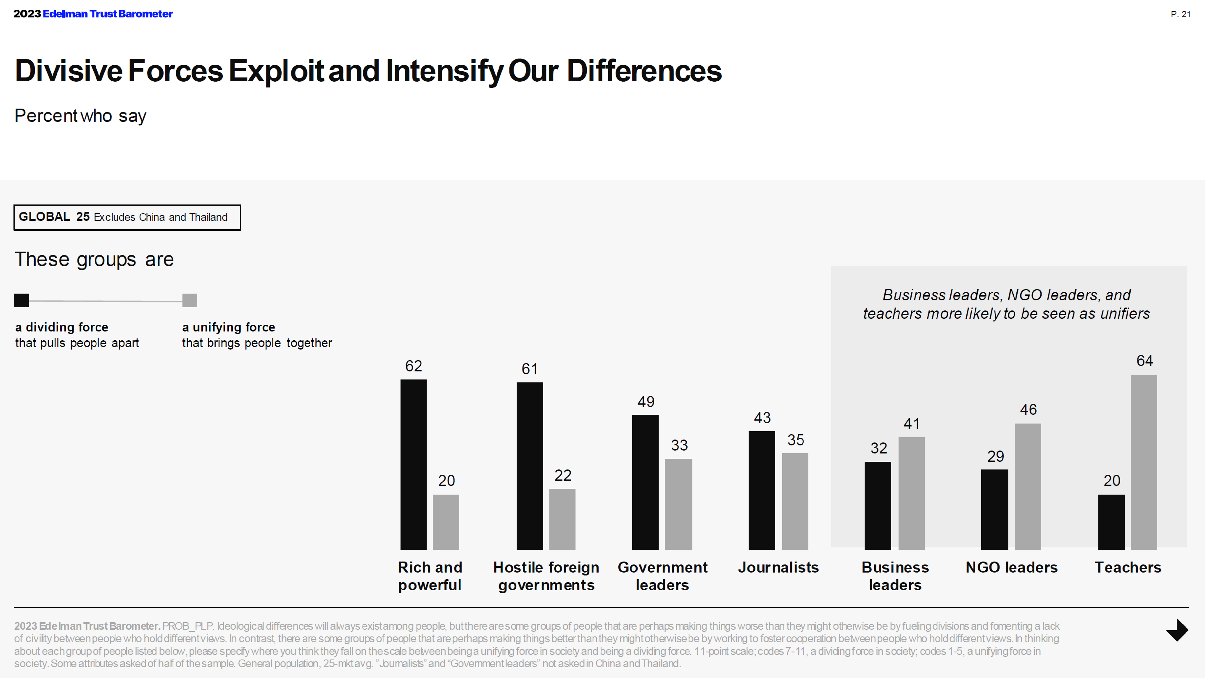
- The intent to villainize.

“The language that was once reserved for truly repulsive characters—Adolf Hitler, for example—can now be directed at anyone we disagree with. Spend even a few hours on social media reading about the contentious issues of the day, and you’ll find dozens of people being called Nazis, fascists, authoritarians, genocidal, and so on. It’s no longer enough to say someone has a different view; we now have to make them a villain.”

Session 3: The Appeal of the Disinformation Manipulators

Key Scripture

“For the time is coming when people will not endure sound teaching, but having itching ears they will accumulate for themselves to suit their own passions, and will turn away from listening to truth and wander off into myths. As for you, be sober minded.” (II Tim. 4:3-5)
- The Target of the Manipulators

Who are the manipulators targeting?
“The reason why conspiracy theories spread so easily is because they are psychologically attractive; they offer simple explanations for complex events; they restore a sense of urgency and control in a world, increasingly filled with chaos and uncertainty.”

Manipulators target those with:

- Theological concerns.
- Existential concerns.
- Those seeking an individual sense of relevancy.
- Those seeking a corporate/herd sense of relevancy.
- The Appeal of the Manipulators
- The emotional appeal: The mind justifies what the heart has chosen.

“The motivated brain, selectively and often consciously seeks out or rejects evidence in a way that supports what you already believe. Our thinking, and reasoning processes often start out with a goal. Your thoughts are often inevitably guided by your pre-existing beliefs, or motivations to help you achieve that goal. When your face with something we value enjoy, or care deeply about goals, and motivations often come into play.”

- Our attention and perception are therefore selective.

- Emotions are often the main drivers of our actions.

- When we use our mind to justify our emotional choices we are insecure because our truth is based on human desire and is self-oriented rather than transcendent.

“We cannot tolerate being wrong about the concepts and facts that we rely upon to govern how we live our lives.”
- The pull on intellectual insecurity: Confirmation bias.

- Confirmation bias internally validates our choice.

- Confirmation bias is the tendency to:

“Confirmation bias isn’t limited to how we search for information; it also drives us to interpret information in a way that confirms or supports our preexisting beliefs or values and to avoid or ignore information that might challenge those beliefs and values.”
- The draw to relational validation: Echo chambers.

- Echo chambers externally validate our choice.

- The echo chamber validates our yearning for group identity.

- “Sometimes we willingly distort our perception of the evidence for social purposes, because we have a deep need to belong and identify with like-minded others.”

- “Powerful social forces attract people to change their minds, lead them down specific paths, keep them among fellow misbelievers, and even accelerate the extremity of their beliefs. A sense of community and belonging is a powerful draw and is particularly important in cases where people feel disconnected or ostracized from mainstream society.”

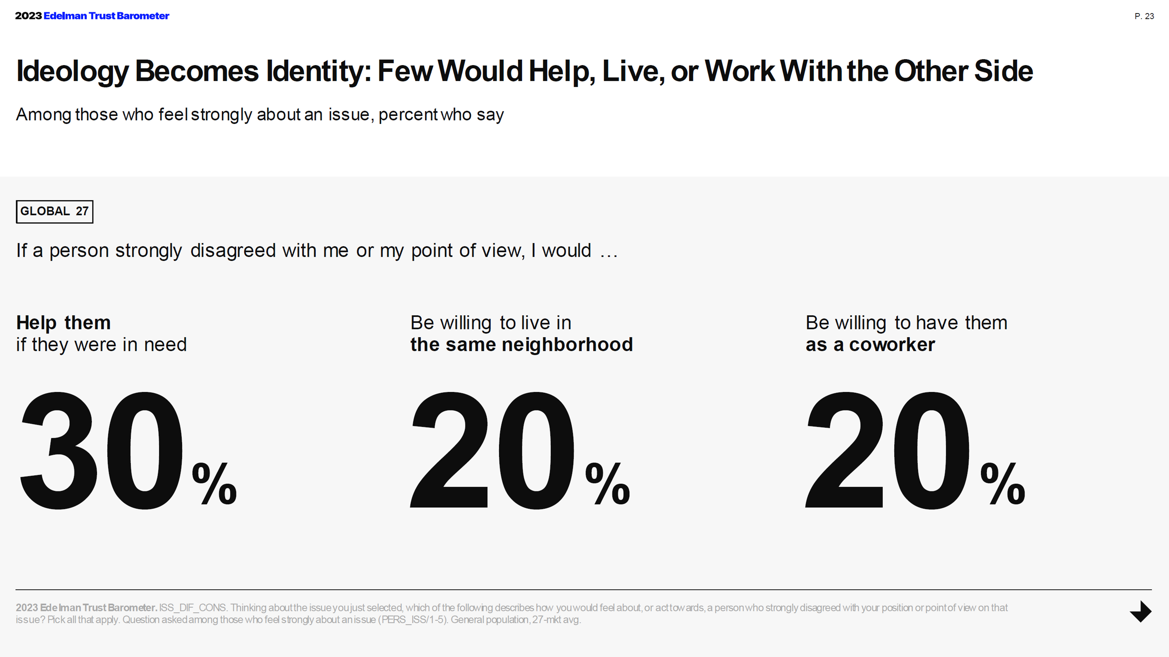
- Appealing to reason usually ends badly.

- Appealing to heart issues is more effective.

- Assuage fear by recognizing concerns.

- Appeal to a realignment of faith.

Conclusion
“The reason why conspiracy theories spread so easily is because they are psychologically attractive; they offer simple explanations for complex events; they restore a sense of urgency and control in a world increasingly filled with chaos and uncertainty.” Sander Van Der Linden. Foolproof.
Session 4: Using Critical Thinking to Dispel Misinformation

Key Scriptures

“Then the king commanded…to bring some of the people of Israel…[those] skillful in all wisdom, endowed with knowledge, understanding learning, and competent to stand in the king's palace, and to teach them the literature and language of the Chaldeans…As for these four youths, God gave them learning and skill in all literature and wisdom.” (Dan. 1:4, 17).
- The Daniel Model: Providing Wisdom and Critical Thinking in an Age of Distrust

- Daniel’s intellectual virtues

Virtue | Intellectual Action | Exemplified by Daniel
Curiosity |  | Daniel asked the captain of the king’s guard, “why is this decree so urgent?” (Dan. 2:15).
Autonomy |  | Daniel knew that reliance on the intellectual elite was not possible. (Dan. 2:27-28).
Courage |  | Daniel volunteered to discern the kings dream in the face of death. (Dan. 2:16).
Humility |  | Daniel did not take credit for his insight. (Dan. 2:23).
Open-mindedness |  | Daniel had skill in understanding the literature of the Babylonians. (Dan. 17)

- Daniel’s intellectual skills

“As for these four youths, God gave them learning and skill in all literature and wisdom.” (Dan. 1:4, 17). Learning: (Hebrew: mada): To discern, to distinguish, to consider.
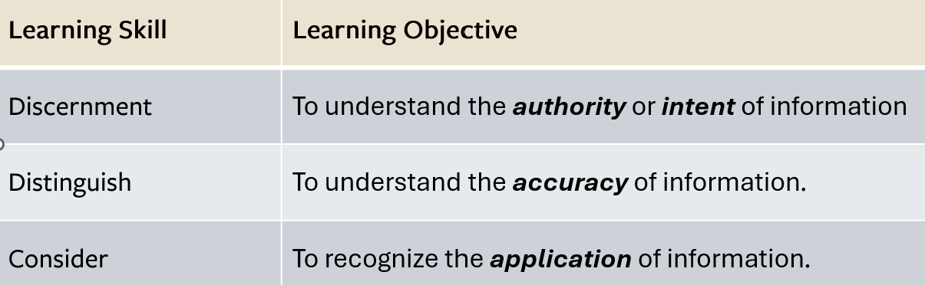

- The skill to discern. Objective: Understand the authority or intent of information.
The ability to discern is gained by asking questions:

- The skill to distinguish. Objective: Understand the accuracy of information.

The ability to distinguish is gained by asking questions:

- The skill to consider. Objective: Recognize the application of information.
The ability to consider is gained by asking questions:
Wise leaders can discern what is important, distinguish the difference between truth and opinion, and consider how to present information and knowledge in a way that provides practical value to others.

Session 5: Practical Tools of Discernment

Key Scriptures

“You shall not spread a false report. You shall not join hands with a wicked man to be a malicious witness.” (Ex. 23:1)

“Put false ways far from me and graciously teach me your law!” (Ps. 119:29)

“It is the glory of God to conceal things, but the glory of kings is to search things out.” (Prov. 25:2)

“Therefore I consider all your precepts to be right; I hate every false way.” (Ps. 119:128)

- Understand the Difference Between Types of Disinformation

Click bait:

Hoax:

Rumor:

Satire:

Propaganda:

Framing:

Conspiracy theories:

- Understand the Traits of Conspiracy Theories

Keys to identifying a typical conspiracy theory:
- Conspiracy theories are often characterized by:
- Conspiracy theories are deeply wary of:
- Conspirators must have:
- Conspiracy theories must feature:
- Conspiracy theorists often are:
- Conspiracy theories reinterpret events:
- Practical Tools for Evaluating Information Online

- Practice click restraint.
YouTube - 2 min video

- Engage in lateral reading.
YouTube - 3 min video

- Try typing in the opposite of what you believe.

- Apply the journalistic approach.
What: Determine what kind of source something is.

Who: What are the academic or professional credentials of the author?

When: Develop their awareness of the value of more current information over less current information.
Where: Does what you’re finding elsewhere contradict the original piece?

Why: Discern the intent of the author or publisher.

How: How is the information or news supported?
- Detecting Deep Fakes

From MIT Media Lab:
- Pay attention to the face. High-end DeepFake manipulations are almost always facial transformations.
- Pay attention to the cheeks and forehead. Does the skin appear too smooth or too wrinkly? Is the agedness of the skin similar to the agedness of the hair and eyes?
- Pay attention to the eyes and eyebrows. Do shadows appear in places that you would expect?
- Pay attention to the glasses. Is there any glare? Is there too much glare? Does the angle of the glare change when the person moves?
- Pay attention to the facial hair or lack thereof. Does this facial hair look real?
- Pay attention to facial moles.
- Pay attention to blinking.
- Pay attention to the lip movements.

Statistica. https://explodingtopics.com/blog/data-generated-per-day
Williams, James. Stand Out Of Our Light. Freedom and Resistance in the Attention Economy. Cambridge University Press. (2018).
Carr, Nicholas. The Shallows. What the Internet is Doing to Our Brains. (P. 10). 2010. W W Norton & Co Inc; New York, NY.
Simon, Herbert A. Designing Organizations for an Information Rich World. Computers, Communication, and the Public Interest. (1971).
Lukianoff, Greg and Haidt, Jonathan. The Coddling of the American Mind. (P. 71). Penguin Publishing Group. Kindle Edition.
Nichols, Tom. The Death of Expertise: The Campaign against Established Knowledge and Why it Matters (p. 143). Oxford University Press. Kindle Edition.
Nichols, Tom. The Death of Expertise: The Campaign against Established Knowledge and Why it Matters (p. 42). Oxford University Press. Kindle Edition.
Anna Tong. AI threatens humanity’s future, 61% of Americans say: Reuters/Ipsos poll. https://www.reuters.com/technology/ai-threatens-humanitys-future-61-americans-say-reutersipsos-2023-05-17/
Nichols, Tom. The Death of Expertise: The Campaign against Established Knowledge and Why it Matters (p. 157). Oxford University Press. Kindle Edition.
Aïmeur, E., Amri, S. & Brassard, G. Fake news, disinformation and misinformation in social media: a review. Soc. Netw. Anal. Min. 13, 30 (2023). https://doi.org/10.1007/s13278-023-01028-5
Linden. Sander van der. Foolproof. Why Misinformation Infects Our Minds and How to Build Immunity. 2023. W W Norton and Company. New York, NY.
Ross, A. S., & Rivers, D. J. (2018). Discursive Deflection: Accusation of “Fake News” and the Spread of Mis- and Disinformation in the Tweets of President Trump. Social Media + Society, 4(2). https://doi.org/10.1177/2056305118776010
Van Der Linden, Sander. Foolproof. Why Misinformation Infects Our Minds and How to Build Immunity. P.196-201.
Ariely, Dan. Misbelief: What Makes Rational People Believe Irrational Things (p. 74). HarperCollins. Kindle Edition.
Van Der Linden, Sander. Foolproof. Why Misinformation Infects Our Minds and How to Build Immunity. P.59.
Van Der Linden, Sander. Foolproof. Why Misinformation Infects Our Minds and How to Build Immunity. P. 33.
Nichols, Tom. The Death of Expertise: The Campaign against Established Knowledge and Why it Matters (p. 67). Oxford University Press. Kindle Edition.
Ariely, Dan. Misbelief: What Makes Rational People Believe Irrational Things (p. 74). HarperCollins. Kindle Edition. P. 127.
Van Der Linden, Sander. Foolproof. Why Misinformation Infects Our Minds and How to Build Immunity. P.36.
Ariely, Dan. Misbelief: What Makes Rational People Believe Irrational Things (p. 74). HarperCollins. Kindle Edition. P. 36.
Aïmeur, E., Amri, S. & Brassard, G. Fake news, disinformation and misinformation in social media: a review. Soc. Netw. Anal. Min. 13, 30 (2023). https://doi.org/10.1007/s13278-023-01028-5)
Ariely, Dan. Misbelief: What Makes Rational People Believe Irrational Things (p. 74). HarperCollins. Kindle Edition. P. 56-57.
Elmwood, Victoria. The Journalistic Approach: Evaluating Web Sources in an Age of Mass Disinformation. Communications in Information Literacy, v14 n2 Article 6 p269-286. 2020.
https://www.media.mit.edu/projects/detect-fakes/overview/

